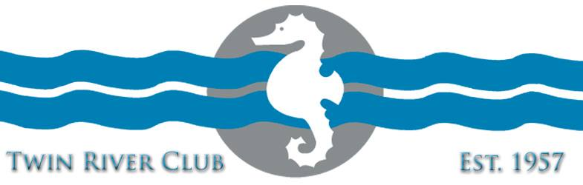

Welcome to TRC Swim Team! We’re thrilled you’ve chosen to participate in a great summer experience with us!

Sky Hendricks will be the lead contact person for the swim team this year. She will be available to answer questions and guide you through the summer. She will bring any concerns you have to the TRC board.

We have a new and enthusiastic young swim coach this year! Her name is Sydney Schmidt. She graduated from Bishop Carroll and she’s currently enrolled at Sterling College. Watch facebook for a more proper introduction and some background info on our new coach! We’re very excited to work with her and learn from her expertise this summer!

We are always in need of swim team sponsors! If you have a connection with someone who owns a business, please let us know!

Same song, no new verses. LOL. Parents will need to be available to time at every meet we have. We are a small program. In order to prevent double duty to families, we have to grow our team which grows the number of volunteers available. Please help us grow by inviting your friends to get their kids involved. It’ll keep their kids busy, healthy and entertained for most of the summer! They’ll develop friendships and team spirit while improving their strokes and becoming safer in the water.

We ALWAYS need to look toward the future….we need more officials in order to sustain our team. At this time we have 1 stroke and turn judge with children on the team. Every other official we have is remaining on board for us because TRC is an awesome place and they want to see kids having fun swimming….but their kids are done. Please consider helping the team by committing to officials training! Please let Sky know if you’d be willing to support our kids in this way.

See the back for our swim meet schedule:

Meet Schedule
Tuesday June 8 TRC At Haysville

Tuesday June 15 VC at TRC

Tuesday June 22 TRC at Derby

Tuesday, June 29 TRC at Winfield

Tuesday, July 6 El Dorado at TRC

Tuesday, July 13 TRC at Wellington

All regular meet start times are at 6:00. All report times will be announced by the coach.

League Finals will be Friday, July 16 and Saturday July 17 in Winfield.
League finals times will be announced.

Feel free to contact us at any time! We are here for you!

Sky Hendricks 316-640-3695 sky.hendricks@yahoo.com

Hope Phan 316-209-1165 hopephan64@att.net

